**FOOD DELIVERY COST AND PROFITABILITY ANALYSIS**

Food Delivery Cost and Profitability Analysis is a comprehensive evaluation aimed at understanding and optimizing the financial dynamics of a food delivery operation. The goal is to identify areas where the service can reduce costs, increase revenue, and implement pricing or commission strategies that enhance profitability.

**TASKS TO CONDUCT**

1. **Detailed Cost Analysis**: Identifying the major cost components associated with delivering food orders, including direct costs like delivery fees and indirect costs like discounts and payment processing fees.
2. **Profitability Evaluation**: Calculating the profitability of individual orders and aggregating this data to assess overall profitability. This involves examining how revenue generated from commission fees measures against the total costs.
3. **Strategic Recommendations for Improvement**: Based on the cost and profitability analysis, identifying actionable strategies to reduce costs, adjust pricing, commission fees, and discount strategies to improve profitability. This includes finding a “sweet spot” for commission and discount percentages that ensures profitability across orders.
4. **Impact Simulation of Proposed Strategies**: Simulating the financial impact of the recommended strategies on profitability, using the dataset to forecast how adjustments in commission rates and discount strategies could potentially transform current losses into profits.

# **ANALYSIS:**

1) IMPORT DATA:

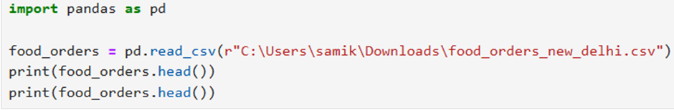

2) DATA CLEANING:

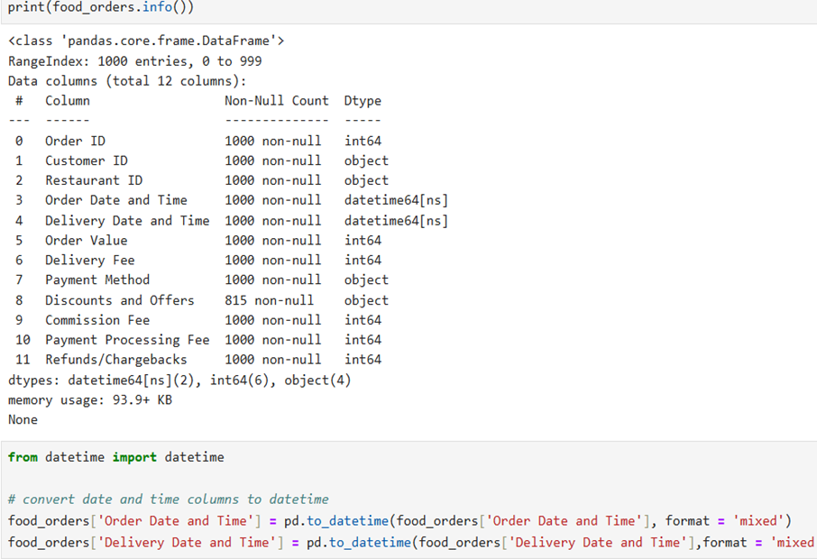

# **COST AND PROFITABILITY ANALYSIS:**

For the cost analysis, we considered the following costs associated with each order:

* **Delivery Fee**: The fee charged for delivering the order.
* **Payment Processing Fee**: The fee for processing the payment.
* **Discount Amount**: The discount provided on the order

The revenue for the platform is mainly derived from the **Commission Fee**. We calculated the net profit by subtracting the total costs (including discounts) from the revenue generated through commission fees.

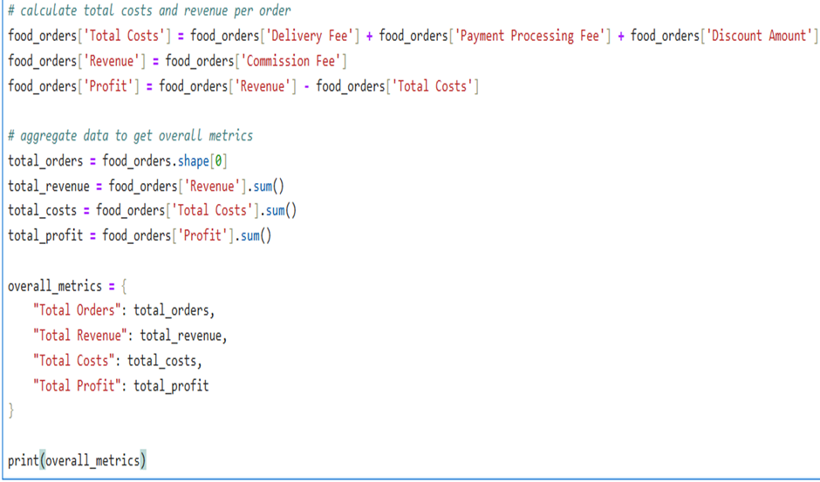

* Total Orders: 1,000
* Total Revenue (from Commission Fees): 126,990 INR
* Total Costs: 232,709.85 INR (including delivery fees, payment processing fees, and discounts)
* Total Profit: -105,719.85 INR

# **VISUALISATION:**

**1.**   **Histogram of profits per order to visualize the distribution of profitable and unprofitable orders.**

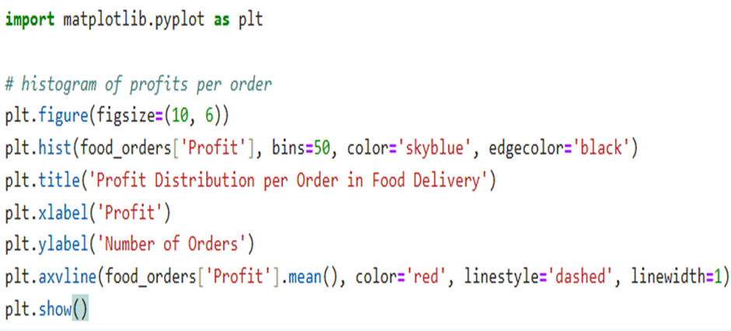

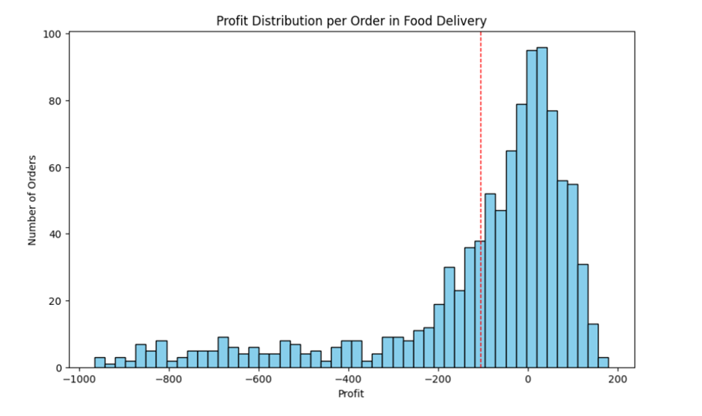

The histogram shows a wide distribution of profit per order, with a noticeable number of orders resulting in a loss (profits below 0). The red dashed line indicates the average profit, which is in the negative territory, highlighting the overall loss-making situation.

**2.**  **A pie chart to visualize the proportion of total costs (delivery fees, payment processing fees, and discounts).**

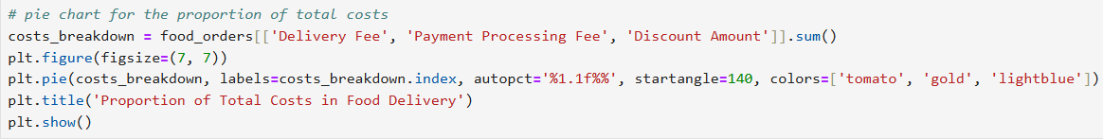

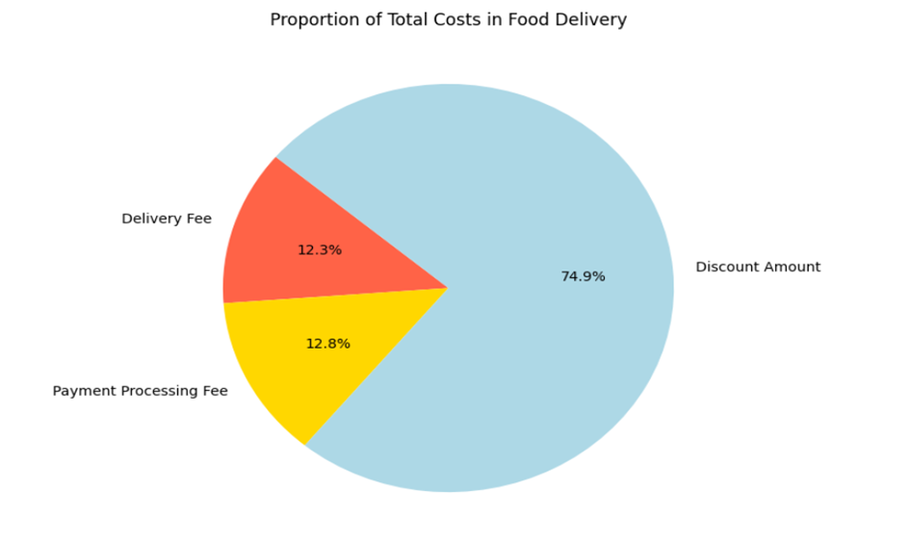

The pie chart illustrates the breakdown of total costs into delivery fees, payment processing fees, and discount amounts. Discounts constitute a significant portion of the costs, suggesting that promotional strategies might be heavily impacting overall profitability.

**3. A bar chart to compare total revenue, total costs, and total profit.**

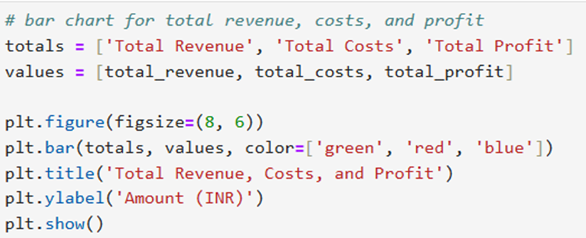

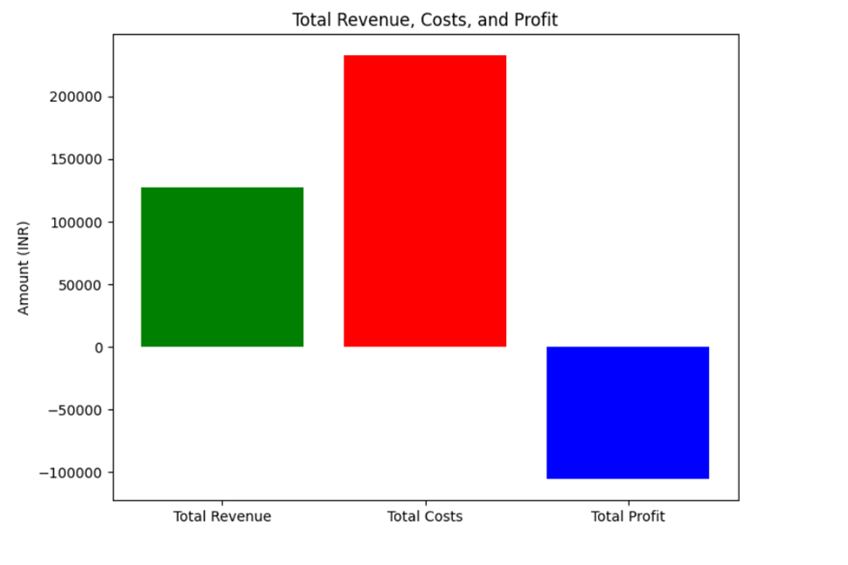

The bar chart compares total revenue, total costs, and total profit. It visually represents the gap between revenue and costs, clearly showing that the costs surpass the revenue, leading to a total loss.

# **INSIGHTS:**

1) The analysis indicates that the total costs associated with the food delivery operations exceed the total revenue generated from commission fees, resulting in a net loss. It suggests that the current commission rates, delivery fees, and discount strategies might not be sustainable for profitability.

2) Discounts constitute a significant portion of the costs, suggesting that promotional strategies might be heavily impacting overall profitability.

# **A NEW STRATEGY FOR PROFITS:**

From the analysis so far we understood that the discounts on food orders are resulting in huge losses. Now, we need to find a new strategy for profitability. We need to find a sweet spot for offering discounts and charging commissions. To find a sweet spot for commission and discount percentages, we can analyse the characteristics of profitable orders more deeply. Specifically, we need to look for:

1. A new average commission percentage based on profitable orders.

2. A new average discount percentage for profitable orders, that could serve as a guideline for what level of discount still allows for profitability.

Given these new averages, we can suggest adjustments that might not only make individual orders profitable but also apply broadly across all orders to improve overall profitability.

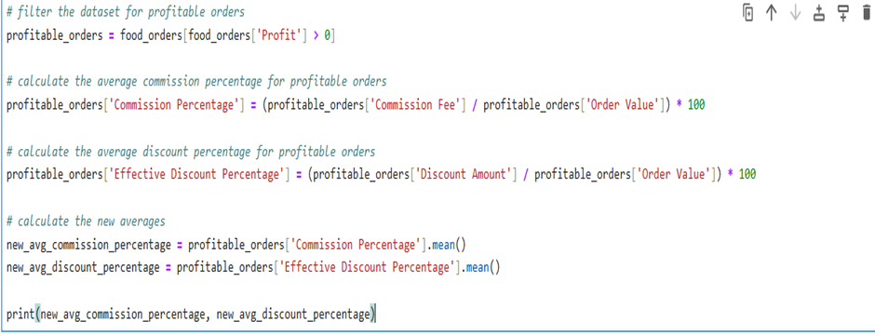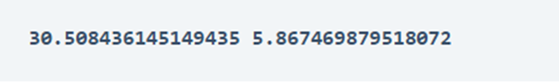

* New Average Commission Percentage: 30.51%
* New Average Discount Percentage: 5.87%

Based on this analysis, a strategy that aims for a commission rate closer to **30%** and a discount rate around **6%** could potentially improve pofitability across the board.

# **POTENTIAL IMPACT OF PROPOSED STRATEGIES:**

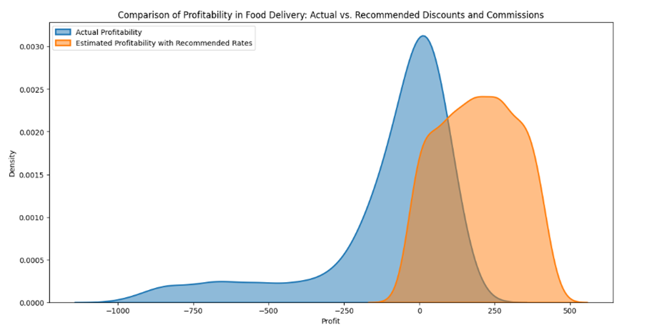

The visualization compares the distribution of profitability per order using actual discounts and commissions versus the simulated scenario with recommended discounts (6%) and commissions (30%).

The actual profitability distribution shows a mix, with a significant portion of orders resulting in losses (profit < 0) and a broad spread of profit levels for orders. The simulated scenario suggests a shift towards higher profitability per order. The distribution is more skewed towards positive profit, indicating that the recommended adjustments could lead to a higher proportion of profitable orders.

### 

# **SUMMARY:**

Food Delivery Cost and Profitability Analysis involved examining all the costs associated with delivering food orders, from direct expenses like delivery fees and packaging to indirect expenses like discounts offered to customers and commission fees paid by restaurants. By juxtaposing these costs against the revenue generated (primarily through order values and commission fees), the analysis aimed to provide insights into how profitable the food delivery service is on a per-order basis.

Based on this analysis, a strategy that aims for a commission rate closer to **30%** and a discount rate around **6%** could potentially improve pofitability across the board.